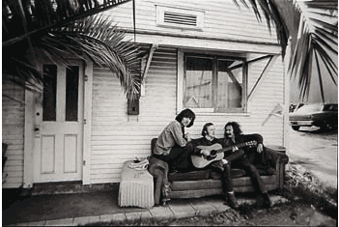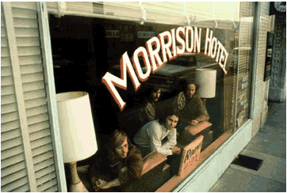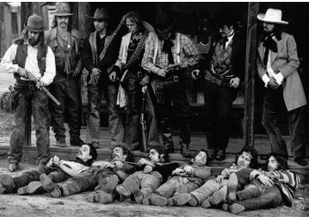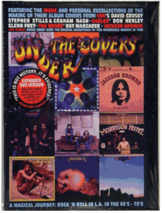

ELECTRONICS RETAILER PACKAGE FOR THE ROCK ART SHOW
As the exclusive Electronics Retailer of the Rock Art Show, there are many exciting ways to integrate your retail product in the show.
- Set up a Big Screen or Plasma TV with a DVD player at the Rock Art Show and show the DVD “Under the Covers” featuring photographer Henry Diltz and some of his subjects including Crosby, Stills & Nash, The Doors and the Eagles. This DVD always gets a crowd as Henry shows where and how his famous album covers were taken. Your retailer will have signage on the TV.
- Arrange an enter-to-win or auction off a piece of electronics gear at the Art Show. All proceeds for the auction will go to the charity.
- Offer discount certificates for electronics items at the Rock Art Show.

HERE’S WHAT ELSE YOU WILL RECEIVE:

- Inclusion in (100) on-air announcements, both live and pre-recorded, to air between (dates).
- Opportunity to distribute literature on-site at the Rock Art Show exhibit.
- Logo exposure at the Rock Art Show in an upscale, high traffic venue.
- Ability to coupon at the Rock Art Show.
- Ability to give away product at the Art Show or auction off one product for charity.
- (26) VIP passes to the Opening Night Gala.
- On-Site signage and framed window signage @ Mall Location,
- Inclusion in (mall) Activity boards.
- Full-page advertisement in the Rock Art Show program (if you choose to do a program)
- Logo inclusion and hyperlink from (radio station) web page featuring the event.
- Logo inclusion in radio station posters for the event to be distributed in sponsor locations and throughout the mall.
- Inclusion in radio station email blast to its Loyal Listener data base.

Total Value: $

