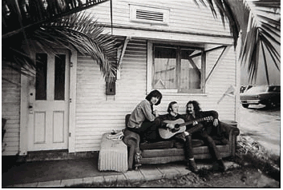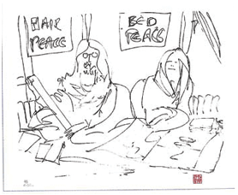
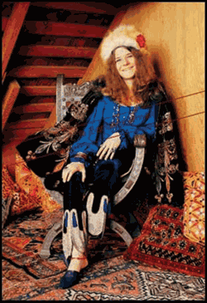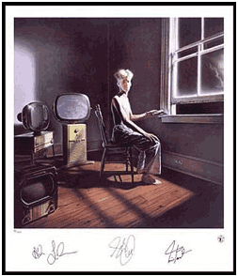

FURNITURE RETAILER PACKAGE FOR THE ROCK ART SHOW
As the exclusive Furniture Retailer of the Rock Art Show, there are many exciting ways to integrate your retail product in the show.

- Set up a sofa and/or a chair at the Rock Art Show in front of the TV that is showing Rock Art videos. You will receive signage around the Rock Art Show lounge area.
- Set up a chair surrounded by Rock Art works (see above) of chairs, sofas and beds. Put a framed certificate next to the chair and take bids on it with the high bidder winning the chair. All proceeds go to a local charity.
- Give out certificates at the Rock Art Show valid for a discount on any furniture purchase.

HERE’S WHAT ELSE YOU WILL RECEIVE:

- Inclusion in (100) on-air announcements, both live and pre-recorded, to air between (dates).
- Opportunity to distribute literature on-site at the Rock Art Show exhibit.
- Logo exposure at the Rock Art Show in an upscale, high traffic venue.
- Ability to coupon at the Rock Art Show.
- Ability to give away product at the Art Show or auction off one product for charity.
- (26) VIP passes to the Opening Night Gala.
- On-Site signage and framed window signage @ Mall Location,
- Inclusion in (mall) Activity boards.
- Full-page advertisement in the Rock Art Show program (if you choose to do a program)
- Logo inclusion and hyperlink from (radio station) web page featuring the event.
- Logo inclusion in radio station posters for the event to be distributed in sponsor locations and throughout the mall.
- Inclusion in radio station email blast to its Loyal Listener data base.

Total Value: $

