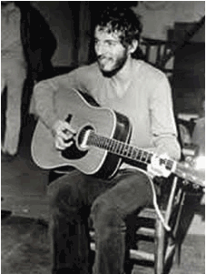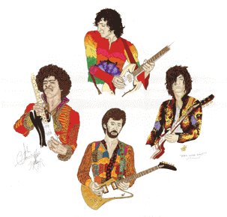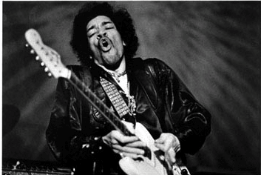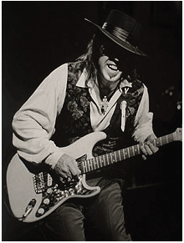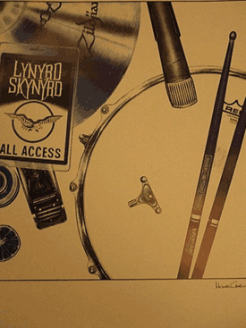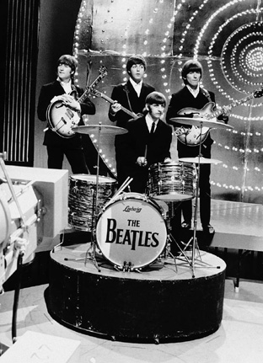

GUITAR/MUSICAL INSTRUMENTS RETAILER PACKAGE FOR THE ROCK ART SHOW
As the exclusive Guitar/Musical Instrument Retailer of the Rock Art Show, there are many exciting ways to integrate your retail product in the show.
- You can assemble a Rock Band set up at the show (drums, guitars on stands, microphones) as props. Easels can be set up behind each instrument featuring a piece of art from a famous musician. For example, we would put an easel of Ringo Starr behind the drums, an easel of Pete Townshend and Jimi Hendrix behind the guitar microphones, etc. There would be a signed placed next to the band set up featuring your logo.
- The Rock Art Show can set up a wall of famous rock stars playing their instruments. This wall can be sponsored by your retail location, complete with signage.
- Give away or auction off a guitar at the show for charity.
HERE’S WHAT ELSE YOU WILL RECEIVE:

- Inclusion in (100) on-air announcements, both live and pre-recorded, to air between (dates).
- Opportunity to distribute literature on-site at the Rock Art Show exhibit.
- Logo exposure at the Rock Art Show in an upscale, high traffic venue.
- Ability to coupon at the Rock Art Show.
- Ability to give away product at the Art Show or auction off one product for charity.
- (26) VIP passes to the Opening Night Gala.
- On-Site signage and framed window signage @ Mall Location,
- Inclusion in (mall) Activity boards.
- Full-page advertisement in the Rock Art Show program (if you choose to do a program)
- Logo inclusion and hyperlink from (radio station) web page featuring the event.
- Logo inclusion in radio station posters for the event to be distributed in sponsor locations and throughout the mall.
- Inclusion in radio station email blast to its Loyal Listener data base.

Total Value: $

