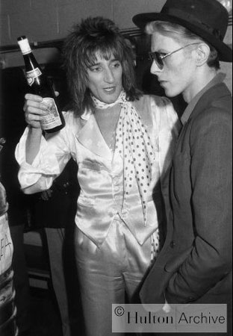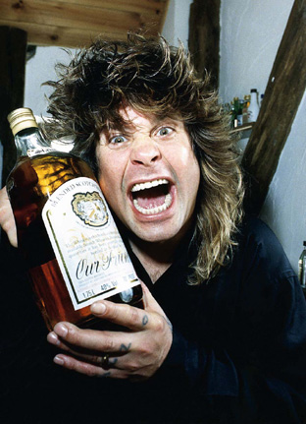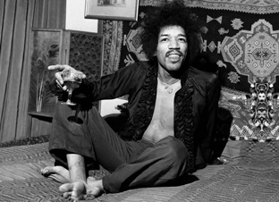

ROCK STARS LIKE THEIR LIQUOR
SPIRITS PACKAGE FOR THE ROCK ART SHOW
As the exclusive liquor of the Rock Art Show, there are many exciting ways to integrate your retail product in the show.
- The Rock Art Show will feature a section of the show with photographs of rock stars holding drinks. Examples shown are Rod Stewart & David Bowie, Ozzy Osbourne and Jimi Hendrix. The liquor sponsor will provide a sign or signs that will hang with the fine art photographs that says “Rock Stars like their liquor” or something similar.

- The sponsoring spirits distributor can serve at the VIP reception on opening night featuring radio personnel, clients, media, local celebrities and the sponsoring charity. Signage will accompany the drink station. (Venue approval needed).

- Sponsoring liquor can have an on premise night at a local club or tavern for listeners. Give away an art print at the on premise night.

HERE’S WHAT ELSE YOU WILL RECEIVE:

- Inclusion in (100) on-air announcements, both live and pre-recorded, to air between (dates).
- Opportunity to distribute literature on-site at the Rock Art Show exhibit.
- Logo exposure at the Rock Art Show in an upscale, high traffic venue.
- Ability to coupon at the Rock Art Show.
- Ability to give away product at the Art Show or auction off one product for charity.
- (26) VIP passes to the Opening Night Gala.
- On-Site signage and framed window signage @ Mall Location,
- Inclusion in (mall) Activity boards.
- Full-page advertisement in the Rock Art Show program (if you choose to do a program)
- Logo inclusion and hyperlink from (radio station) web page featuring the event.
- Logo inclusion in radio station posters for the event to be distributed in sponsor locations and throughout the mall.
- Inclusion in radio station email blast to its Loyal Listener data base.

Total Value: $

