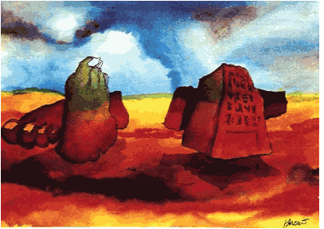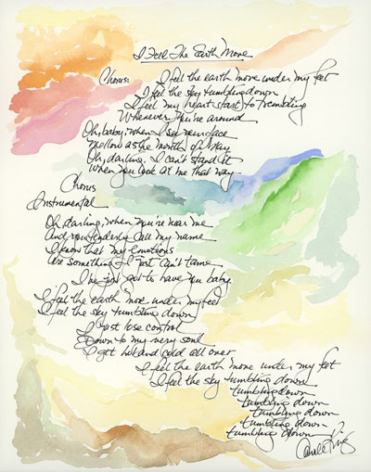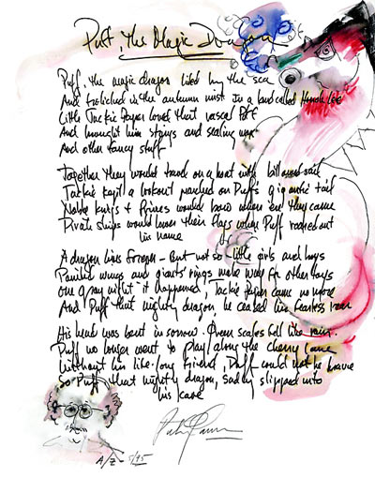

MARINA/BOATING PACKAGE FOR THE ROCK ART SHOW
As the exclusive Marina/Boating Retailer of the Rock Art Show, there are many exciting ways to integrate your retail product in the show.
- The Rock Art Show can put together a display of rock stars “Water”colors sponsored by your Marina or Boating Retailer. Watercolors will include (pictured above): Jon Anderson (Yes), Jerry Garcia, Michael Clarke (Byrds), Carole King, Peter, Paul & Mary and more. Your signage will appear prominently on the watercolor display.
- The Rock Art Show can offer free “Shipping” on all art purchases courtesy of your Marina or Boating Retailer.
- You can give away or auction off one of your products at the show for charity.
HERE’S WHAT ELSE YOU WILL RECEIVE:

- Inclusion in (100) on-air announcements, both live and pre-recorded, to air between (dates).
- Opportunity to distribute literature on-site at the Rock Art Show exhibit.
- Logo exposure at the Rock Art Show in an upscale, high traffic venue.
- Ability to coupon at the Rock Art Show.
- Ability to give away product at the Art Show or auction off one product for charity.
- (26) VIP passes to the Opening Night Gala.
- On-Site signage and framed window signage @ Mall Location,
- Inclusion in (mall) Activity boards.
- Full-page advertisement in the Rock Art Show program (if you choose to do a program)
- Logo inclusion and hyperlink from (radio station) web page featuring the event.
- Logo inclusion in radio station posters for the event to be distributed in sponsor locations and throughout the mall.
- Inclusion in radio station email blast to its Loyal Listener data base.

Total Value: $

