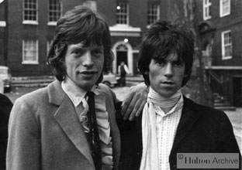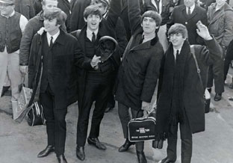
ROCK STARS LOOK COOL IN SUITS
MEN’S CLOTHIER PACKAGE FOR THE ROCK ART SHOW
As the exclusive Men’s Clothier of the Rock Art Show, there are many exciting ways to integrate your retail product in the show.
- The Rock Art Show will feature a section of the show with photographs of rock stars such as the Beatles and the Rolling Stones in suit and ties. The retailer will provide a sign or signs that will hang with the fine art photographs that says “Rock Stars look cool in suits and a logo for your retail location.

- If you choose, you can provide a mannequin wearing one of your latest fashions. The Rock Art Show will hang a piece of art around the mannequin so in essence, the mannequin becomes an easel for the artwork. Signage can accompany the mannequin with fashions courtesy of XYZ Retailer.

- You can distribute coupons and/or special offers to your retail store at the Rock Art Show.

- If you happen to carry Jerry Garcia neckwear at your retail store, the Rock Art Show can put together a collection of Jerry Garcia artwork with displays of the ties.

HERE’S WHAT ELSE YOU WILL RECEIVE:

- Inclusion in (100) on-air announcements, both live and pre-recorded, to air between (dates).
- Opportunity to distribute literature on-site at the Rock Art Show exhibit.
- Logo exposure at the Rock Art Show in an upscale, high traffic venue.
- Ability to coupon at the Rock Art Show.
- Ability to give away product at the Art Show or auction off one product for charity.
- (26) VIP passes to the Opening Night Gala.
- On-Site signage and framed window signage @ Mall Location,
- Inclusion in (mall) Activity boards.
- Full-page advertisement in the Rock Art Show program (if you choose to do a program)
- Logo inclusion and hyperlink from (radio station) web page featuring the event.
- Logo inclusion in radio station posters for the event to be distributed in sponsor locations and throughout the mall.
- Inclusion in radio station email blast to its Loyal Listener data base.

Total Value: $

