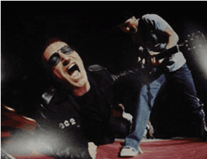
WIRELESS PACKAGE
FOR THE ROCK ART SHOW

As the exclusive Wireless sponsor of the Rock Art Show, there are many ways to integrate your product into the show.

- Hold a photo contest using only your camera phone. Post the best entries at the art show.
- The radio station will take photos from the Rock Art Show during its run using your brand’s camera phone. They will send it back to the radio station website for posting on the station web site.
- Demonstrate cellular services by offering free phone calls from the Rock Art Show.
- Distribute literature and/or bounce back coupons highlighting the new cellular services.
- Offer 10% off any rock art purchase with a cellular activation during the Rock Art Show.

HERE’S WHAT ELSE YOU WILL RECEIVE:

- Inclusion in (100) on-air announcements, both live and pre-recorded, to air between (dates).
- Opportunity to distribute literature on-site at the Rock Art Show exhibit.
- Logo exposure at the Rock Art Show in an upscale, high traffic venue.
- Ability to coupon at the Rock Art Show.
- Ability to give away product at the Art Show or auction off one product for charity.
- (26) VIP passes to the Opening Night Gala.
- On-Site signage and framed window signage @ Mall Location,
- Inclusion in (mall) Activity boards.
- Full-page advertisement in the Rock Art Show program (if you choose to do a program)
- Logo inclusion and hyperlink from (radio station) web page featuring the event.
- Logo inclusion in radio station posters for the event to be distributed in sponsor locations and throughout the mall.
- Inclusion in radio station email blast to its Loyal Listener data base.

Total Value: $

