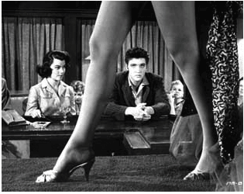

BEER SPONSOR FOR THE ROCK ART SHOW

- The sponsoring beer can serve at the VIP reception on opening night featuring radio personnel, clients, media, local celebrities and the sponsoring charity. Signage will accompany the drink station. (Venue approval needed).

- Sponsoring beer can have an on premise night at a local club or tavern for listeners. Give away an art print at the on premise night.

- Give away tickets courtesy of the sponsoring beer to one of the Rock Art Show featured artists upcoming area concert.

- Give away a piece of art, such as the Doors Gold Record, at an on-premise night or at a retailer.

HERE’S WHAT ELSE YOU WILL RECEIVE:

- Inclusion in (100) on-air announcements, both live and pre-recorded, to air between (dates).
- Opportunity to distribute literature on-site at the Rock Art Show exhibit.
- Logo exposure at the Rock Art Show in an upscale, high traffic venue.
- Ability to coupon at the Rock Art Show.
- Ability to give away product at the Art Show or auction off one product for charity.
- (26) VIP passes to the Opening Night Gala.
- On-Site signage and framed window signage @ Mall Location,
- Inclusion in (mall) Activity boards.
- Full-page advertisement in the Rock Art Show program (if you choose to do a program)
- Logo inclusion and hyperlink from (radio station) web page featuring the event.
- Logo inclusion in radio station posters for the event to be distributed in sponsor locations and throughout the mall.
- Inclusion in radio station email blast to its Loyal Listener data base.

Total Value: $

