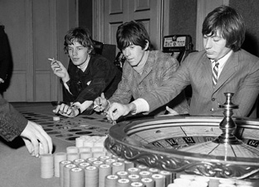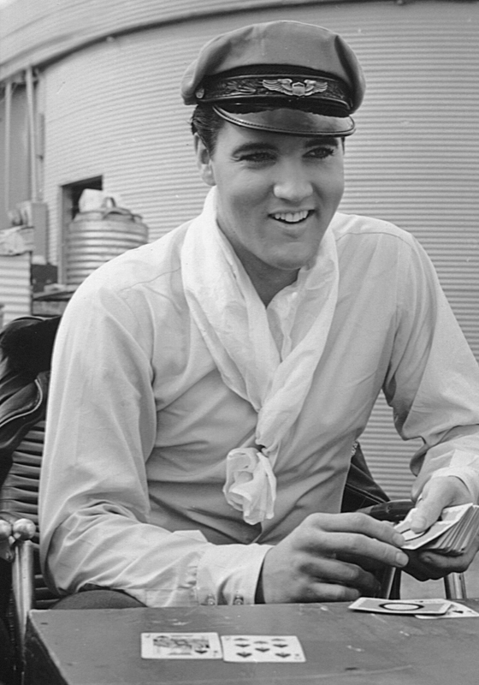

CASINO PACKAGE FOR THE ROCK ART SHOW
As the exclusive Casino of the Rock Art Show, there are many exciting ways to integrate your casino in the show.

- In conjunction with the Rock Art Show, give away a copy of the London Times Mirror photograph of the Rolling Stones playing roulette entitled, “Tumbling Dice.”
- If allowed by law, give away a $5 or $10 chip from the casino to everyone who makes an art purchase during the Rock Art Show.
- Give away or auction off a night at the hotel or if appropriate, two tickets to an upcoming concert. If auctioned off, all money will go to charity.
- Host the actual Rock Art Show at your casino.

HERE’S WHAT ELSE YOU WILL RECEIVE:

- Inclusion in (100) on-air announcements, both live and pre-recorded, to air between (dates).
- Opportunity to distribute literature on-site at the Rock Art Show exhibit.
- Logo exposure at the Rock Art Show in an upscale, high traffic venue.
- Ability to coupon at the Rock Art Show.
- Ability to give away product at the Art Show or auction off one product for charity.
- (26) VIP passes to the Opening Night Gala.
- On-Site signage and framed window signage @ Mall Location,
- Inclusion in (mall) Activity boards.
- Full-page advertisement in the Rock Art Show program (if you choose to do a program)
- Logo inclusion and hyperlink from (radio station) web page featuring the event.
- Logo inclusion in radio station posters for the event to be distributed in sponsor locations and throughout the mall.
- Inclusion in radio station email blast to its Loyal Listener data base.

Total Value: $

